EE 4341 - Embedded System Design

*Lab 2 - Interfacing with an accelerometer using the SPI protocol*



# Hardware

* PIC32 Starter Kit 3
  + PIC32MX470F512L
* Starter Kit I/O Expansion Board
* PICtail Plus click Adapter
* Micro Bus – RS232 click
* DB9 Extension cable (Male – Female)
* LIS3DH accelerometer

# Software

* MPLAB X IDE v3.51
* XC32 compiler v1.34
* PuTTY

# Background

*Reference files uploaded to Canvas:*

* [PIC32MX470 Family Data Sheet](https://ww1.microchip.com/downloads/en/DeviceDoc/PIC32MX330350370430450470_Datasheet_DS60001185H.pdf)
* [Pictail-plus-click-adapter-schematic-v100-b](https://drive.google.com/file/d/1UwFkQgUUZ01k4m_3wT0FyaMw4YzscyR6/view?usp=sharing)
* [PINOUT_PICtail–PIC32MX470](https://drive.google.com/file/d/1GSwD0xKD-tBkt9Le9_iB7okW2RYApOE8/view?usp=sharing)
* [Section 12. IO Ports](https://drive.google.com/file/d/16lnYkjvQBE5DPLLmM6GH-7YwER8A_vtc/view?usp=sharing)
* [Section 23. SPI](https://drive.google.com/file/d/19fxO7VENkPHQm0vwobwfCLskyXNS87EL/view?usp=sharing)
* [General SPI background](https://en.wikipedia.org/wiki/Serial_Peripheral_Interface)
* [LIS3DH Datasheet](https://drive.google.com/file/d/1zVxcVhhBQCjgo_vnVjqyqtTIlT-KZ2py/view?usp=sharing)
* [LIS3DH Appnote](https://drive.google.com/file/d/1e0c75EP0WGw7s8Sfkk6pRwSKHYJC9jcx/view?usp=sharing)

# Objective

# At the end of this lab you should be able to communicate with an accelerometer via SPI. You will also learn how to create a Library and include it in your main project(page 11). The code skeletons for each function used in this lab are posted on canvas. First, copy/paste all the functions into your main.c file, you will also need to copy/paste the #define statements from the “accel_define.h” file. After your code works, download all files separately, fill the functions in, and create your library.

**Note –** Make sure you have completed Lab 1 (the UART lab) before attempting this one

System Diagram



Peripheral Pin Select

**Objective -** Configure the following: **See –** [PIC32MX470 Family Datasheet](https://ww1.microchip.com/downloads/en/DeviceDoc/PIC32MX330350370430450470_Datasheet_DS60001185H.pdf) / Pages 139-141

| Name | Pin |
| --- | --- |
| SDI2 | RG7 |
| SDO2 | RG8 |
| SS2 | RG9 |

* SDI – Serial Data In – a.k.a “MISO”
* SDO – Serial Data Out – a.k.a “MOSI”
* SS – Slave Select a.k.a – “CS”

SPI(2) Setup

First, make sure your SYSCLK is still configured to 80MHz, and the Peripheral Bus Clock to 40MHz. Second, set up the SPI2 peripheral according to the following specifications:

**See:** *Section 23. SPI* – pages 23-8 → 23-15 and page 23-29

* SCK2 frequency = 39.06 kHz
* Framed support off
* 16 bit communication
* Figure out the values for the CKE and CKP bits
* Master mode
* Sample data at the end of clock time

SPI(2) Read and Write

There are two functions you need to write in order to communicate using the SPI peripheral. Actually, you can write one function that does the same as the two, but having two functions makes it easier to see what is going on when looking at code.

**void** spi2_write_register(**uint16_t** data)

{

// see code skeleton for instructions

}

**int16_t** spi2_read_register(**uint16_t** data)

{

// see code skeleton for instructions

}

The reason that “spi2_read_register” is of type int16_t is specific to the accelerometer we are using. We need to be able to read negative values, so using an unsigned int will not work.

**Note -** The header file “stdint.h” gives you the capability of using precise data types, such as “uint16_t”, when defining functions. Some common ones are shown below: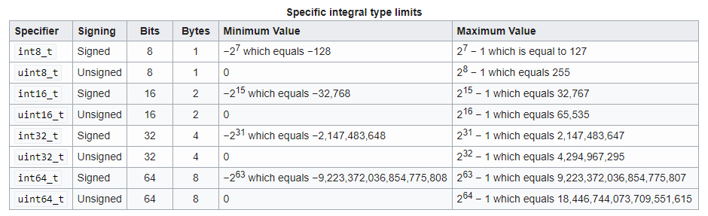

Communicating with the Accelerometer

The SPI read and write protocol, which is discussed in the LIS3DH **Datasheet,** is shown below:

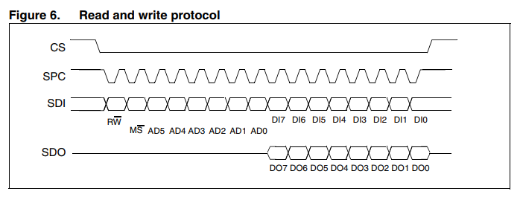

Writing data to a register is simple, and is accomplished with a call to **“**spi2_write_register()”

As shown in the “SDI” bit stream, bit 15 determines whether you are writing or reading, bits 13-8 will contain the address of the register being written to, and bits 7-0 contain the data being written to the register. The “Register Mapping” section of the LIS3DH **Datasheet** contains the addresses and default values for each register.

Below is an example of what you would see on a digital oscilloscope when reading the “WHO_AM_I” register:

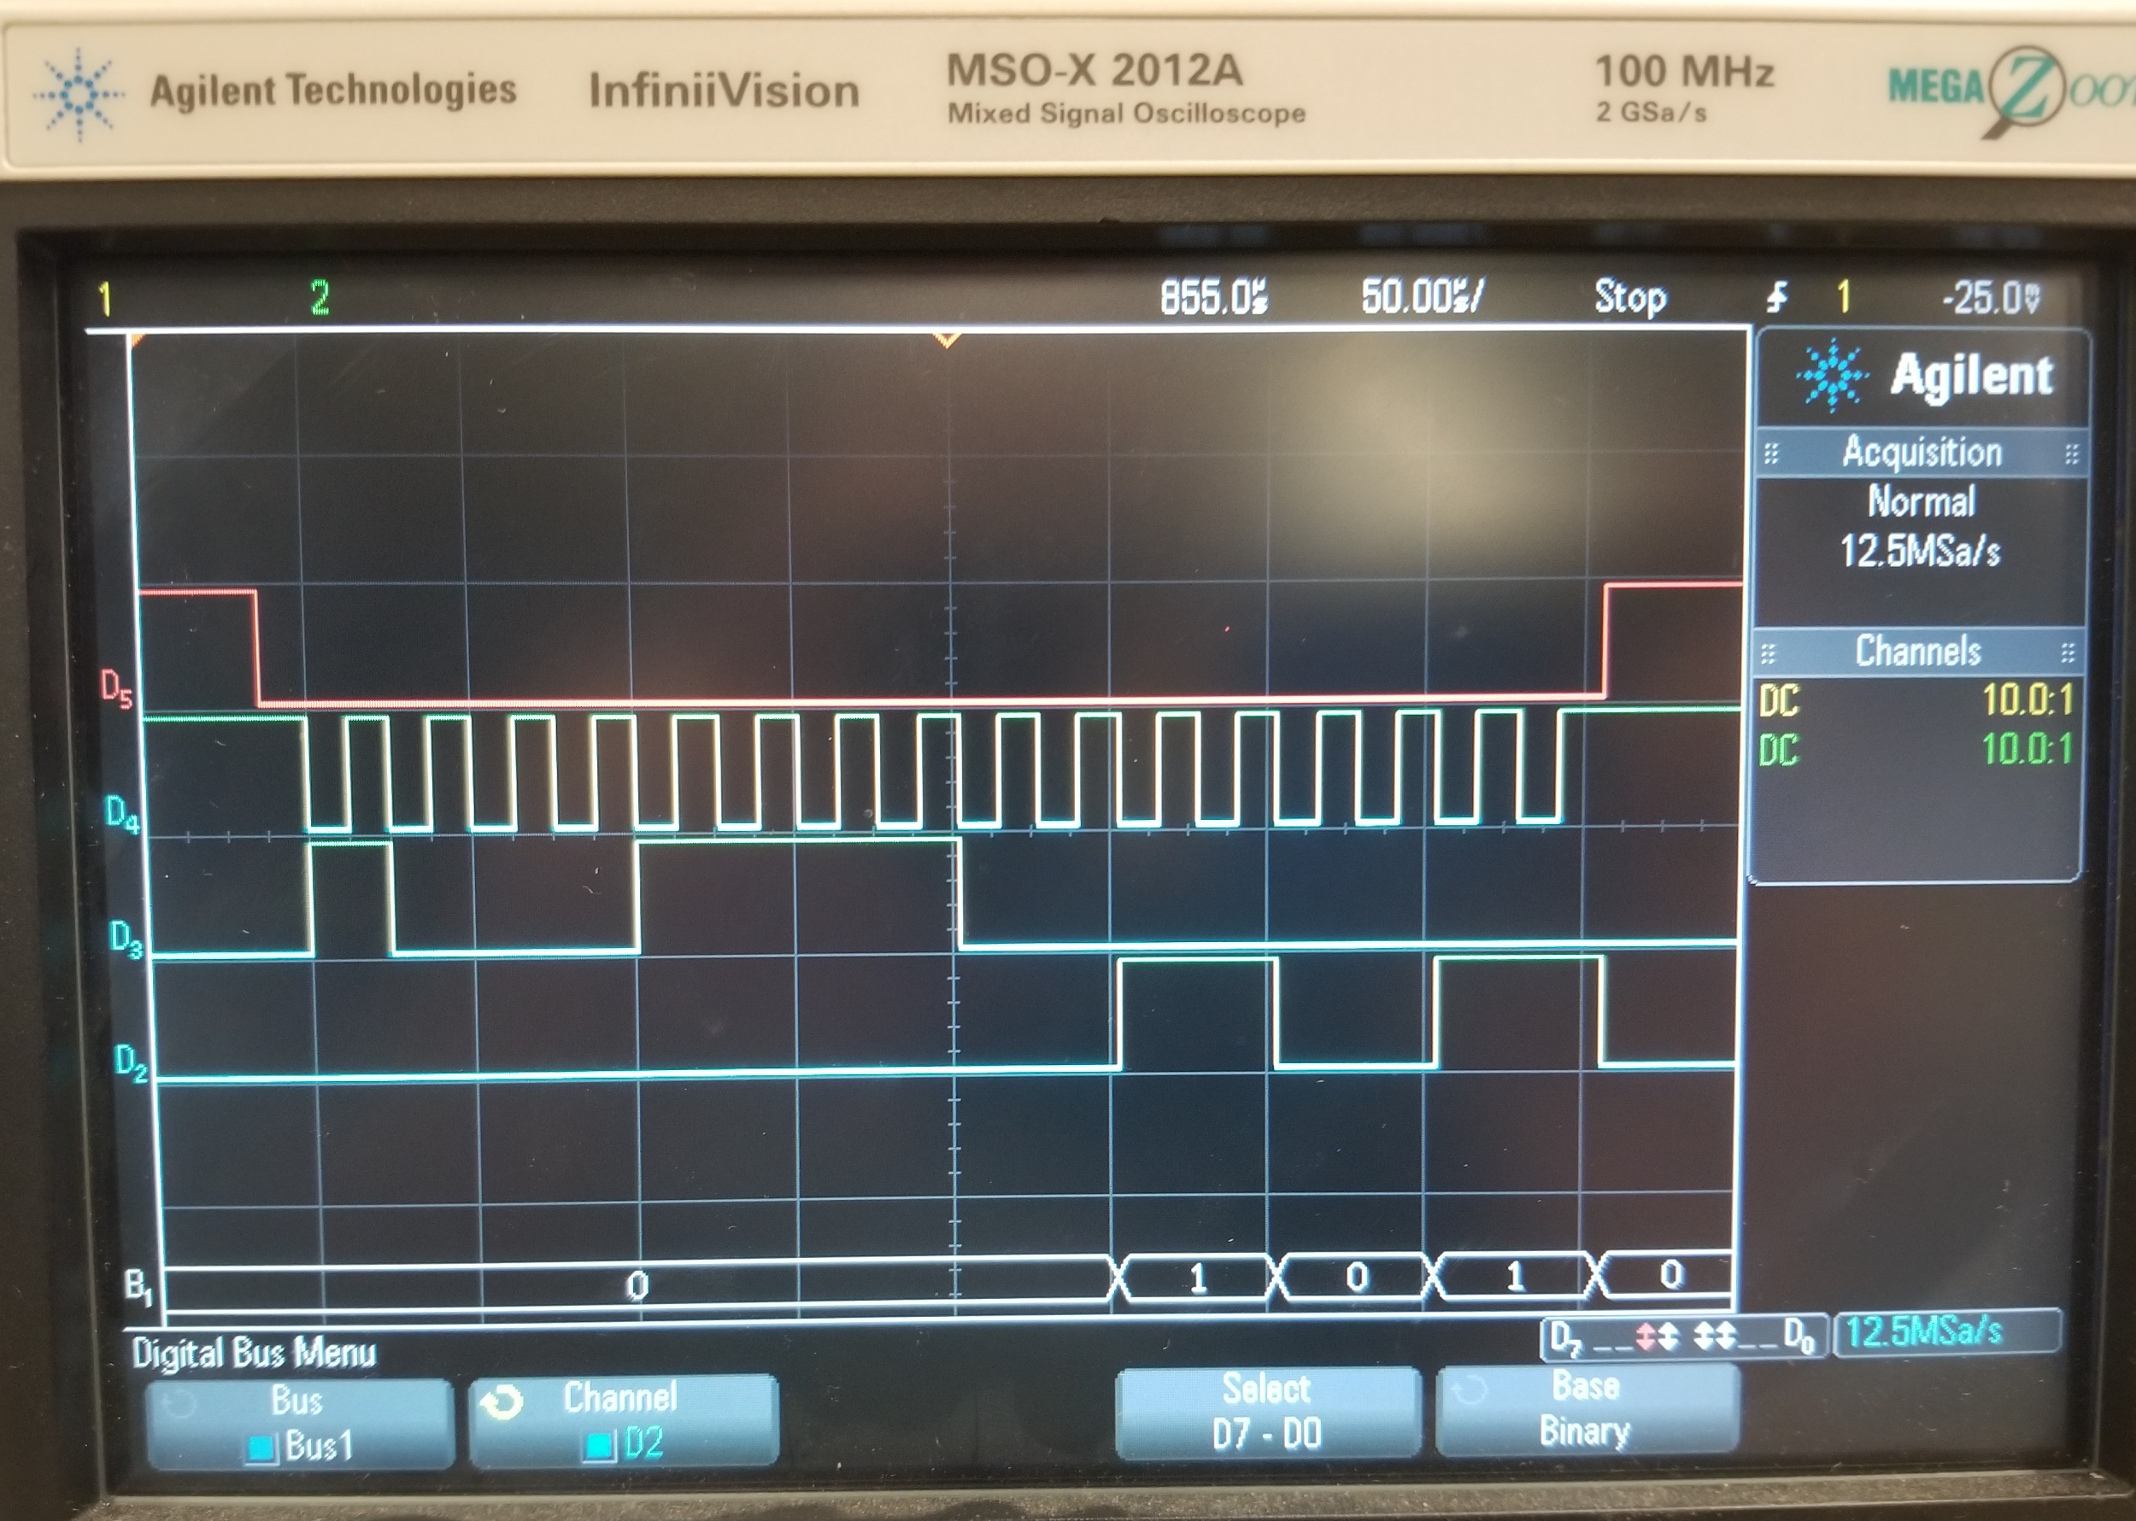

Many devices have registers with fixed values so users can determine whether communication is working. This is an example of such register.

Accelerometer Setup

The recommended procedure to set up the accelerometer, from the LIS3DH **Appnote**, is shown below:

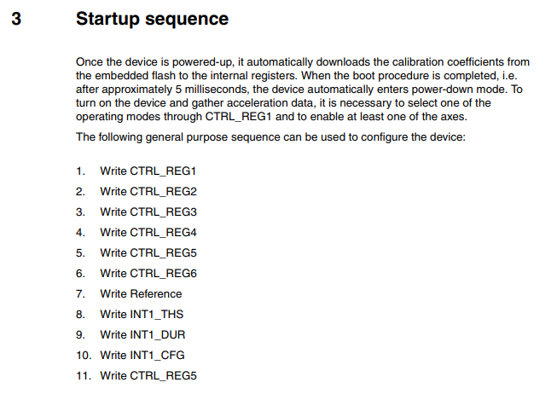

We will follow this procedure except that in step 11 we will be writing to the “FIFO_CTRL” register instead of “CTRL_REG5”.

Reading Accelerometer Data

The SPI read protocol, which is discussed in the LIS3DH **Datasheet,** is shown below.

As shown in Figure 7, even though we are in 16 bit mode, only the least significant byte (LSB): bits 7-0, is important to us. Since the data from each axis (x,y,z) is in the form of a 16-bit signed int, reading from two separate registers is required.

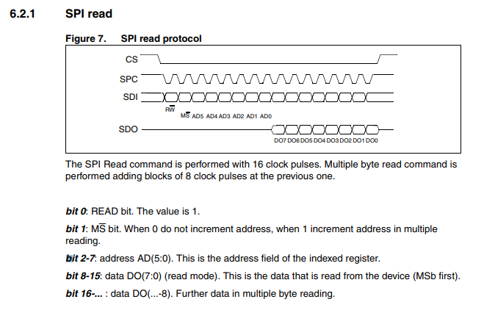

**Pseudo code for reading x-axis data**

accel_read_x()

{

X_H = spi2_read_register(OUT_X_H); // read x-axis MSB

X_L = spi2_read_register(OUT_X_L); // read x-axis LSB

X = X_H and X_L combined into one 16 bit value

return X * 0.000061; // convert to units of g

}

* Scale (CTRL_REG_4): +/- 2g
* Data is 16 bits wide
  + (2-(-2)) / (2^16) = 4 / 65536 = 0.0000610352

Combining the register values can be done using [bitwise operators.](https://www.tutorialspoint.com/cprogramming/c_bitwise_operators.htm)

**Example:**

If X_H == 0b10101111**00110011**, the only bits we want are bits 7-0, which are bolded.

The 8 most significant bits can be deleted, since we don't care about them, using binary and “&”.

→ X_H & 0b0000000011111111 == 0b00000000**00110011**

In order to get X_H in it’s correct position, the important bits will have to be shifted to the left using the binary left shift operator “<<”.

→ X_H shifted to it’s correct position == 0b**00110011**00000000

After following the same procedure for the X_L data, they can be combined using binary or “|”.

→ X = X_H | X_L

Demo

demo.c contains some functions that you can use to demo the accelerometer. Do **not** add this file to your library. The functions that you will use to demo are listed below:

* void test_accel(void)
  + Call this in while(1)
* void accel_print_data(char axis)
* void accel_move_cursor(void)
  + Modify your code so that you can demo these functions by holding the buttons:
    - Button1 → print x-axis data
    - Button2 → print y-axis data
    - Button3 → move cursor

The z-axis will work, but there is a limited range of motion due to wire length, so it is hard to manipulate. A picture with the accelerometer and its coordinate plane is on the following page.

while(1) // this is what your while loop should contain

{

delay(1);

//accel_test();

buttons();

}



The data will change by moving the accelerometer around the x-y plane. However, the easiest way to manipulate data is to *tilt* the accelerometer towards the axis you want to manipulate.

**Note:** Make sure that the LIS3DH pins are in the **correct positions** on mikro bus A, moving wires around can potentially fry the chip. Also, there are two pins, 3Vo and INT, on the accelerometer that should not be connected to anything.

PuTTY output when **test_accel()** is called in main loop:

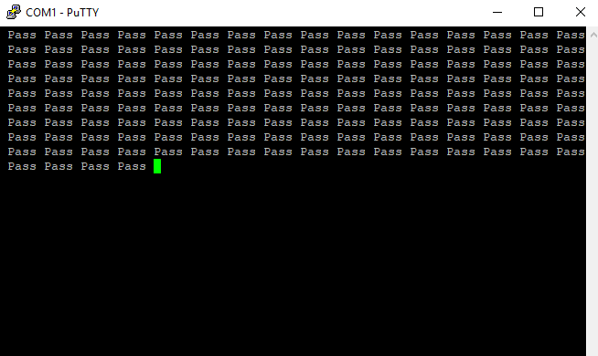

PuTTY output when **BUTTON1 and BUTTON2** are held (separately):

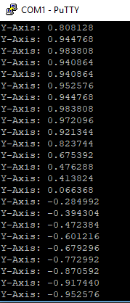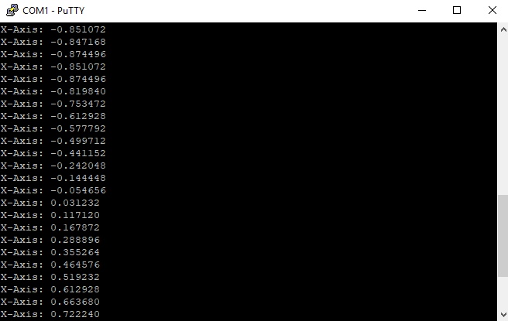

Creating and using a Library

# Libraries are important because they make code modular and accessible in other projects. The .c file skeletons for the library that you are going to build are located in canvas under the “LAB2” section.

Make sure all of your code works before proceeding.

A good general tutorial about creating a library in MPLAB can be found [here](http://microchipdeveloper.com/mplabx:libraries).

To build a Library, create a new project and choose the “Library Project” option:

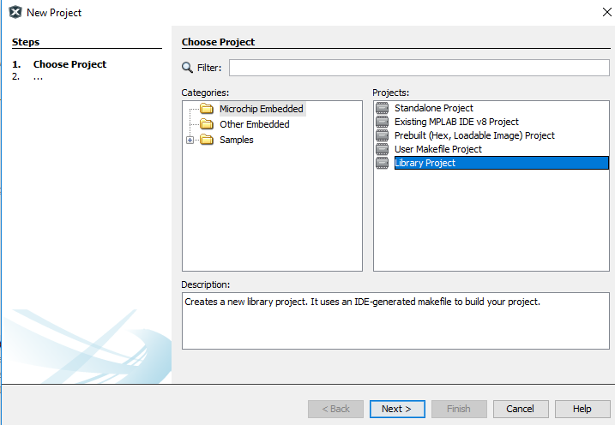

The device to select should appear under the “Recently used” Family. If not, find it again.

PIC32 -> PIC32MX470512L

Select the “Simulator” option then select the XC32 compiler. If not already defined, set the path to C:\Program Files (x86)\Microchip\xc32\v1.34

Name your library as follows: <your x500 id>_accelerometer_spi

In order to access functions in a Library, there needs to be a header file associated with it. Add the .c and .h file(s) from Canvas so that your library folder looks like the picture below (make sure you add them to the directory folder first, the same way you did in lab 0, also, change the name before adding them so your x500 appears):

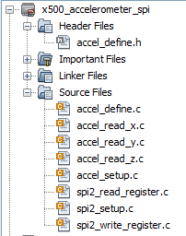

After filling in the functions in the .c files (and making sure they work) clean and build your project.

Your output window should display something like this:

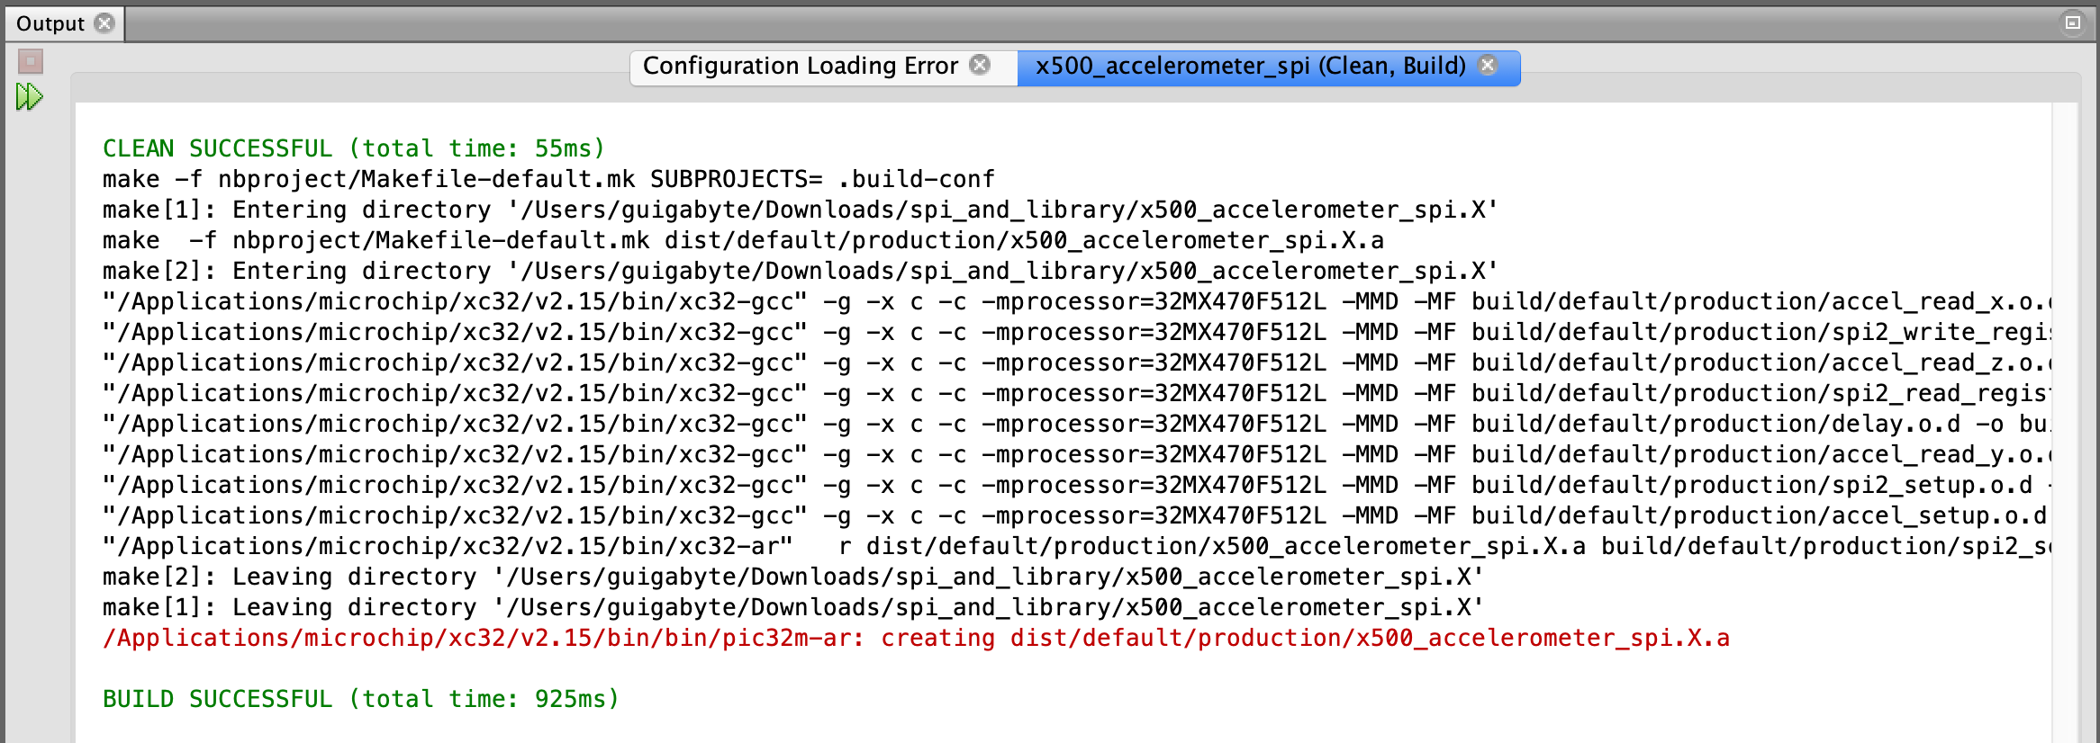

The red line shows the location of the file you want to add to your main project’s “Libraries” folder:

**wherever_your_folder_is/x500_accelerometer_spi.X/dist/default/production**

In your main project folder, right click “Libraries” and click “add Library/Object file”

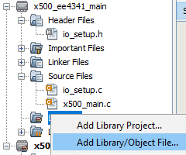

Also, you will need to add the “x500_accelerometer_spi.h” file to the main project using the same process:

1. Rename the file so that your x500 is in it
2. Copy the file to your main project’s directory
3. Right click header files, add existing item, add it

Your main project folder should now look like this:

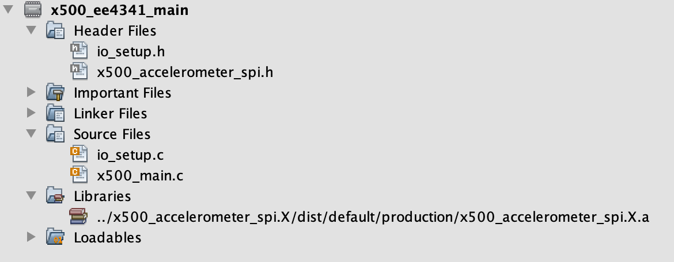

**Note -** All of the header files should be #included in your main file!